Lecture Note on Advanced Igneous Petrology (First part)

By

Dr. M.B GIREI

Phase Equilibria
Introduction: Phase equilibria, which is an application of thermodynamic in igneous petrology provide a way to understand the igneous rock forming processes including partial melting leading to magma generation and magma cooling and crystallization leading to the formation of igneous rocks under both open and closed system conditions.
Some terminology:
System: It is part of the universe that one can isolate (either physically or mentally) for the purpose of study. Types of system:
1) Open System: A system may be open, if it can transfer energy and matter to and from the surroundings.
2) Closed System: In a closed system, only energy, such as heat, may be exchanged with the surroundings.
3) Isolated System: Neither energy nor matter may be transferred with the surroundings.
• Surroundings: Surroundings can be considered the as part of the universe just outside the system.
• Phase: Phase is defined as a chemically and physically homogenous part of a system that is bounded by an interface with adjacent phases.
• System Components: Smallest number of chemical constituents needed to make up all phases in the system.
• Variance (also known as the Degrees of Freedom, expressed as "f"):
Minimum number of variables that need to completely define the state of a system at equilibrium.

Phase Rule governs the number of phases that can co-exist in an equilibrium in the system and is expressed as:
F=C-P+2 or F+P=C+2
Where, P= Number of phases present in a system
F= Degree of Freedom
C= Components
2= Two intensive parameters usually T (temperature) and P (pressure).
In cases, where either P or T is kept constant, one can apply the condensed phase rule with the formula: F=C-P+1
Two component Systems
Some terminologies
1.) Equilibrium crystallization is the process whereby the crystallizing minerals remain in contact with the melt throughout the crystallizing process.
2) Fractional crystallization is a process in which crystallizing minerals are immediately extracted from the melt and do not react with it further. In nature, fractional crystallization can occur in one of two processes: 1) crystals may be removed from communication with the melt when they sink to the bottom of a magma chamber, or 2) crystals may be left behind as the melt moves away in a process called filter pressing.
3) Equilibrium melting is a process whereby the melt and the residuum remain in communication throughout the melting process.
4) Fractional melting models a system where melt is extracted from a system as soon as it forms and does not react further with the residuum.

- Systems with Complete Solid Solution (Albite-anorthite system)
Minerals with very similar mineral lattice structures mix easily on the atomic scale. This phenomenon is defined as solid solution of one phase with the other phase. The most common example in the igneous petrology which shows such behaviour is of olivine and plagioclase minerals. Now, let us define the term mixed crystals and solid solution series. When the two components are isomorphous and miscible in all proportions in solid state, they form homogeneous crystals which are called as mixed crystals. Solid solution forms where both components are isomorphous and constituent ions have similar ionic radius and equal ionic charge. In this case, both the components in solid and melt phases change during equilibrium crystallization and both the components mixed completely with each other.

Fig. 1: Isobaric T-X phase diagram for Albite-Anorthite (Ab-An) system at atmospheric pressure
Now you will learn about binary system with complete solid solution of the two end members with the help of Albite (NaAlSi3O8) - Anorthite (CaAl2Si2O8) (Ab- An) system. In Ab-An system, solid solution coupled with Na+1 and Si+4
substitution for Ca+2 + Al+3 in a constant AlSi2O8 reference framework is involved.
In the above Fig. 1, pure albite (Ab) is taken on the right end and the pure anorthite (An) on the left end of the X axis. These two pure systems behave like a typical isobaric one component system. In this system, solid-melt that coexists in a single phase at a fixed temperature in equilibrium (P=2).
When applied in the phase rule (F=C-P+2), it is expressed as
F =1-2+1
F =0 (invariant point)
Pure Ab and An melts at 1118 ºC and 1153 ºC at X and Y points respectively. Now, let us examine what happens when we add a component on either of the pure systems. In the experiment, when we add Ab component to pure An component, the melting point lowers down. In case of addition of pure Ab, melting point rises. Now, let us use the phase rule to analyse the behavior of
melt of an intermediate composition.
Now, first consider a melt of a composition ‘a’ in Fig. 5.5 at 1600 ºC (An60Ab40),
we take it as the bulk composition (X bulk) of the system. At about 1600 ºC, liquid
composition is An60. In this case, the liquid composition is equal to the bulk
composition as the system is entirely of liquid composition. Thus, in this case
P=1(liquid) and C=2.
Applying phase rule (F=C-P+2), we have F = (2+1-1) = 2
This means that for a single two component liquid at a constant pressure, F =2. The two most realistic intensive variables that we can take to define the system include:
1) temperature, and
2) composition (X liqAn or X liqAb).
After cooling the system to point ‘b’ (An60Ab40) in Fig. 1 at about 1475 ºC, plagioclase of composition ‘c’ (An87), which is different from that of the melt beings to crystallise indicating that the initial crystal is An-rich. The line connecting b and c i.e., the composition of the co-existing phases at a definite temperature is called a ‘Tie line’.
Now, with the help of a phase rule, at any point on the liquidus curve, P=2 (coexisting
liquid and solid) and C=2. So, F=2-2+1 = 1
Here, only one intensive variable is sufficient to define a system completely. With continuous cooling, both liquid and solid vary in compositions. The liquid composition changes along the liquidus from b to g in Fig. 1 and the plagioclase changes from c to h indicating that with continuous cooling, both crystal and liquid become more sodic (Ab rich). In this case, the reaction is represented by:
Liquid1 + plagioclase1= liquid2 + plagioclase2
Such reactions having at least one degree of freedom that occur by exchange of components over a range of temperature and or pressure are called continuous reaction and form a series of mixed crystals.
LEVER RULE
Now let us study about lever rule. In addition to their mineralogical compositions, a phase diagram also furnishes information related to the modal proportions of phases. The technique used to find out this information is known as lever rule. It can be used to determine the fraction of liquid and solid phases for a given binary composition and temperature that is between the liquidus and solidus line. Using the length of a tie line at any specific temperature, we can calculate the relative amount of phases in a system. The tie line in the two-phase regions is analogous to a lever balance on a fulcrum. This geometric approach is called “Lever rule”. Let’s consider the tie-line ‘df’
(Fig.2) we can represent it as

Fig. 2: Graphical representation of the abundance of components in a binary
mixture.

According to lever’s rule:
Liquid % = length of line segment (e-f) * 100/ df
Plagioclase% = length of d-e * 100/ df
We can define lever rule as the amount of a given phase in a system is proportional to the length of segment on opposite side of the bulk composition.
The closer a phase to the bulk composition, the more predominant it is. In order to understand lever rule, take help of Fig. 1.
Using this at 1445 ºC,
ef= An82- An60 = 22 and de= An60- An48 = 12, thus
Liquid % = 22*100/(82-48)= 22*100/34 = 64.70 wt%
Solid % = 12*100/34 = 35.29 wt%
If we continue the cooling, with a constant bulk composition, ‘ef’ becomes larger, whereas ‘de’ becomes smaller which is a natural phenomenon, i.e., the % of solid increases with the decrease% in the melt. As the temperature approaches to 1340 ºC, the corresponding solid composition of melt ‘g’ (An22) will be at ‘h’ which is equal to the bulk composition (An60). With continuous cooling, the tiny amount of liquid (An22) is consumed immediately. Here F= 2-1+1 = 2, so we must specify both T and a compositional variable, like in case of liquidus to specify the system.

Note: Detail crystallization and partial melting scenarios under both equilibriums and fractional crystallization have been treated in the class and will not be repeated here. Student should refer to lecture power points.

Petrological Significance of Albite-Anorthite system
During equilibrium and fractional crystallization in albite-anorthite system, the first plagioclase to crystallize is typically more calcic than the coexisting melt (Figure 1), and both the plagioclase and the melt will become more sodic as crystallization proceeds. Plagioclase commonly does not equilibrate easily with the melt, because doing so requires the exchange between calcium and aluminum in the plagioclase and sodium and silicon in the melt. Since both the aluminum and silicon are tightly bound in the tetrahedral site, equilibration (or diffusion) is very slow. This slow diffusion explains why zoned plagioclase is so commonly encountered in igneous rocks, as well as why evolved rocks are enriched in sodium relative to calcium.
- BINARY EUTECTIC SYSTEM
- Diopside-Anorthite
In a binary system, when two mineral components crystallises or melts simultaneously at a particular or fixed temperature, the temperature is called eutectic temperature and the process is called eutectic crystallisation. Opposite to the case, when a mixture of two minerals is heated at a fixed pressure a melt of fixed composition is formed. The temperature at which two minerals are melted is called eutectic melting temperature and the process is called eutectic melting.

Fig. 3: Binary system (Diopside-Anorthite) without solid solution relation.
Fig. 3 represents a simple type of Diopside –Anorthite binary system without solid solution relation (as the Diopside –Anorthite possess different mineral structure, Diopside-single chain inosilicate, Anorthite-tectosilicate). In this case, both the mineral components crystalises out simultaneously only at a particular temperature or a point called eutectic point in a particular fixed proportion. • Crystallisation behaviour on the left side of the eutectic point: Consider
a melt of ‘a’ (Di30An70) composition above the liquidus, P= 1 (only liquid) and C=2, so applying phase ruleF= 2+1-1= 2.
Here two variables, temperature and composition (T, XliqAn or XliqDi) are required to define the system. With cooling, when the melt (Di30An70) touches the liquidus at a point ‘b’ at 1450 ºC, pure Di begin to crystallise. So above liquidus, as F= 2+1-2= 1, only one variable (temperature or composition) is needed to define the system. With further cooling, more and more Di crystals are formed and liquid composition will move away from b towards point d. At point d (1274ºC), anorthite joins diopside and both (Di and An) the mineral components crystalizes out simultaneously at a fixed eutectic temperature and in a fixed eutectic proportion. Cooling to the point ‘g’ (1450 ºC), crystallization of pure ‘Di’ will begin and at that point, F will be = 2-2+1= 1. Here, we have to fix one variable (generally ‘T’). With continuous cooling, the liquid composition changes along the liquidus line from ‘g’ towards ‘d’ and pure anorthite crystals continue to form. This crystallization of ‘An’ from melt is also a continuous reaction which may be represented by:
Liquid1 = solid + liquid2
With continuous cooling, at the eutectic point (1274 ºC), where both the liquidus
converge, there are 3 phases that coexist, and degree of freedom F= 0. This eutectic reaction is a type of equilibrium crystallisation. At eutectic point, we can apply the lever's rule to determine the relative amount of solid and liquid. It has been found that with the progress of time, ratio of solid to liquid that increases.
Note: Detail crystallization and partial melting scenarios under both equilibriums and fractional crystallization have been treated in the class and will not be repeated here. Student should refer to lecture power points.
PETROLOGICAL SIGNIFICANCE OF DIOPSIDE-ANORTHITE SYSTEM
In diopside-anorthite, any liquid with a composition on the anorthite side of the eutectic, such as the one discussed previously, first crystallizes anorthite. Indeed, if the composition is far from the eutectic, anorthite crystallizes over a considerable temperature interval before diopside appears at the eutectic. The early-formed anorthite crystals are consequently larger than later-formed crystals, and a porphyritic texture results, with phenocrysts of anorthite. Phenocrysts are formed from the phase whose liquidus is first encountered by the cooling magma. If volcanic eruption of a melt on the anorthite liquidus results in rapid quenching, the liquid may never crystallize diopside, and the phenocrysts may instead be surrounded by glass. The texture is then said to be vitrophyric.
Had the melt first encountered the diopside liquidus, phenocrysts of this mineral would have formed (Fig. 3). Regardless of which phase forms the phenocryst, the surrounding liquid is always enriched in the eutectic composition.
- Binary Peritectic system
(The forsterite-Silica System)
Some terminologies.
Peritectic Point: This refers to an invariant point on a phase diagram where reaction between a solid and liquid phase will produce a second solid phase. E.g forsterite (Mg₂SiO4) + silica (SiO2)=Enstatite (enstatite).
Solvus: Is a boundary line between homogenous solid solution and individual, immiscible phase forming through process such as exsolution of incongruent melting (i.e the limit of solubility between two components).
Incongruent Melting Reaction: Is a melting reaction in which a solid does not melt uniformly and the liquid produce is not the same composition as the solid (i.e a reaction where melting a solid produce a second solid and a liquid).
Congruent Melting Reaction: Is a melting reaction in which the phases a system is transitioning are the same composition (i.e the liquid form during melting is the same in composition as the solid being melted).

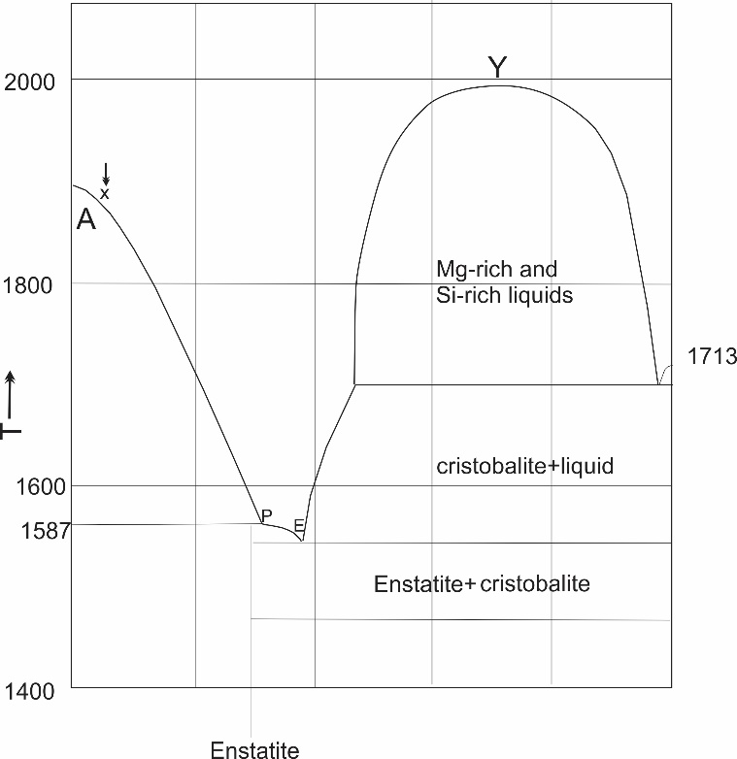
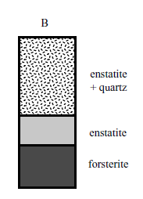

Figure 4: A) Phase diagram for the system Mg₂SiO₄ –SiO₂ showing the path followed by fractional crystallization. (B) The sequences of mineral assemblages encountered in a hypothetical magma chamber of composition X that underwent fractional crystallization.

Equilibrium melting. Equilibrium melting follows the inverse path of equilibrium crystallization. Melting of the assemblage quartz + enstatite begins at the eutectic (1543°C). If the solid assemblage has more quartz than the eutectic composition, enstatite is depleted by melting at the eutectic and the melt moves up the silica + melt curve until all the quartz is depleted from the rock. If the solid assemblage has more enstatite than the eutectic composition, quartz is depleted by melting at the eutectic and the melt moves up the enstatite + silica curve. If the rock contained less enstatite than the composition of the peritectic, then this mineral is depleted from the solid assemblage before reaching the peritectic. If the rock contained more enstatite than the peritectic composition (point P in Figure 4A), then at 1556°C enstatite is entirely removed from the assemblage by reaction with the melt to form olivine. Melt then traverses the olivine-melt curve
until attaining the same bulk composition of the original assemblage. If the original assemblage contained olivine + enstatite, then melting begins at 1556°C. Aft er enstatite is depleted from the rock by peritectic melting, the melt composition moves along the olivine + melt curve. Melting ceases when the melt composition is the same as
the original bulk composition of the system.
Fractional crystallization. In the forsterite-silica system, the path followed during fractional crystallization is different from the trajectory followed during equilibrium crystallization. Equilibrium crystallization of a melt with a composition X will cease at the peritectic (point P in Figure 4A), where all the melt is consumed by peritectic reaction. During fractional crystallization, the olivine is entirely extracted from the system as soon as it forms. As a result, when the melt reaches P, olivine is not available to react with the melt. Since olivine is absent, the melt moves down the liquidus past P, and enstatite begins to crystallize in place of olivine. Enstatite crystallization drives the melt to E, the enstatite-silica eutectic (Figure 4A). Thus, in fractional crystallization, all melts reach the eutectic regardless of initial composition. Whereas magmas that crystallize by the process of equilibrium crystallization form a rock with the same bulk composition as the original magma, magmas undergoing fractional crystallization form a series of rocks of different compositions. Consider what rock sequence would result if a melt of composition X was emplaced into a magma chamber and crystallized entirely by fractional crystallization (Figure 4 B). If the first grains to crystallize, olivine, sink to the bottom of the magma chamber, they form a layer of pure dunite. As the subsequent melt crosses the peritectic, enstatite crystallizes and may accumulate above the olivine-rich layer. At the eutectic, the remainder of the melt crystallizes to an assemblage of 60 percent enstatite and 40 percent quartz. The sum of the abundances of olivine, enstatite, and quartz in this theoretical magma chamber
will equal the initial bulk composition of the magma. Applying the lever rule defines the exact proportions of the minerals formed in Figure 4 B.
Fractional melting. In fractional melting, a rock with the original assemblage enstatite + silica, melting begins at 1543°C (the eutectic temperature; Figure 4A). If enstatite is depleted during melting, quartz melts next when the temperature reaches 1712°C. If quartz depletes during melting, the next melting occurs at the peritectic (1556°C) where enstatite converts to olivine. Further melting occurs only when the temperature increases to the melting point of olivine (1890°C).
Note: Detail crystallization and partial melting scenarios especially those involving solvus has been discussed during lecture. Student can refer to the lecture power point.
PETROLOGICAL SIGNIFICANCE OF FORSTERITE-SILICA SYSTEM
The peritectic reaction for the system forsterite-silica is critical in igneous petrology because it provides a mechanism by which olivine saturated melt can evolve to form silica-saturated rocks. Magnesian olivine and quartz are incompatible, yet it is not uncommon for olivine-bearing igneous rocks to evolve toward silica-saturated, residual melts. Because during fractional crystallization, a melt can pass through the orthopyroxene peritectic and produce a silica-enriched melt while leaving an olivine-rich residue behind.

- Binary Systems with a Thermal Barrier
(The Nepheline-Silica System)
The albite nepheline–silica (SiO2) system, which has the interior phase albite, is a good example of binary system with thermal barrier (Figure 5). Albite melts congruently, meaning this system has two eutectics, one where the melt crystallizes to nepheline + albite and another where the melt crystallizes to silica + albite. As noted previously, the highest temperature at which any phase melts is when it melts to its own composition. Thus if a melt in the NaAlSiO 4 – SiO2 system has the composition of pure albite, it will crystallize directly to albite. If however, a small amount of silica or nepheline is added to the system, the melt will crystallize at a lower temperature than the pure albite system.
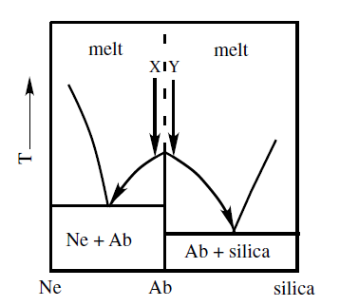

Figure 5: Phase diagram for the system NaSiO4 – SiO2 showing how crystallization of two melts with similar compositions can produce very diff erent residual melts.

Equilibrium Crystallization. Figure 5 depict the system NaAlSiO4 – SiO2 to show the effect of a thermal barrier on equilibrium crystallization. Consider two melts, X and Y, that have very similar composition; X is slightly less siliceous than albite whereas Y is slightly more siliceous. Upon crystallizing albite, melt X moves toward Ne-rich compositions and eventually reaches the nepheline + albite eutectic. In contrast, crystallization of albite from melt Y drives the melt composition to more silica-rich compositions and eventually to the albite + silica eutectic. Because crystallization of the melt always involves extraction of albite, there is no way a melt can move from the silica-saturated field to the nepheline-saturated field, making the albite composition a thermal barrier. Since a system with a thermal barrier is simply a system with two eutectics, the paths followed by fractional crystallization, equilibrium melting, and fractional melting will be similar to those observed in a system with a single eutectic
PETROLOGICAL SIGNIFICANCE OF THE NEPHELINE-SILICA SYSTEM
The thermal barrier represented by the albite composition plays an important role in the evolution of igneous rocks. Owing to the thermal barrier imposed by albite, there is no similar way a nepheline-saturated melt can evolve to quartz-saturated compositions by fractional crystallization. The thermal barrier means that two basaltic melts with only slightly different compositions (one slightly silica saturated and one slightly nepheline saturated) will evolve two distinctly different residual melts, one rhyolitic (equivalent to the albite-silica eutectic in Figure 5) and the other phonolitic (equivalent to the nepheline-albite eutectic in Figure 5). Thus, assuming closed system condition, two co-existing silica undersaturated and silica over-saturated rocks (e.g phonolite and rhyolite) are unlikely to be co-magmatic even if they are temporally related. Refers to lecture power point for details.
- Solid Solution with Eutectic
The albite –orthoclase (alkali feldspars) system

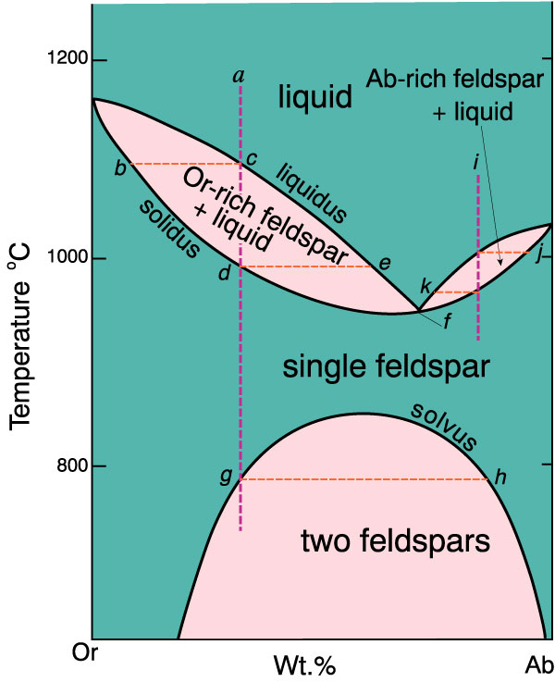

Figure 6: T-X phase diagram of the system albite-orthoclase at 0.2 GPa H₂O pressure

Figure 6 show an albite-orthoclase system at about 0.2 GPa water pressure, which is above the alkali feldspar solvus. An alkali feldspar crystallizing which, initially, is richer than the liquid in either the albite component (e.g “i” in figure 6) or potassium feldspar component (e.g “a” in figure 6) depending on which side of the minimum it falls. Eventually, under equilibrium conditions, a single feldspar crystallizes whose composition is that of the starting liquid. If the liquid is fractionated, compositions approaching the minimum, which is at approximately 70% Ab, will form. On reaching the solvus, the single feldspar unmixes into sodium- and potassium-rich fractions (perthite), which upon further cooling descend on opposite sides of the solvus.
If water is added to this system at 500 MPa, it dissolves in the liquid and lowers the chemical potential of alkali feldspar. Water is not soluble in the solid feldspar, nor does it cause hydrous minerals to form. Therefore, water does not affect the chemical potential of the solids, and the resultis a lowering of the alkali feldspar liquidus. The system is now really ternary, but because the added component, H2O, does not form a crystalline phase, the representation as a simpler binary system is permissible as long as we remember that the melt is not truly binary but contains water. The pressures in such systems are commonly recorded in the petrologic literature as PH2O, the subscript indicating the hydrous nature of the system. As the water content of the alkali feldspar melt increases, so the liquidus temperature progressively decreases. At 500 MPa, however, the melt becomes saturated in water when it reaches 10 wt%, and no further lowering of the liquidus
temperature can occur. Any additional water at this pressure forms a separate vapor phase. By increasing the pressure, however, more water can be dissolved in the melt and the liquidus temperature is lowered still further. Conversely, decreasing the pressure decreases the ability of the melt to contain water and raises the liquidus temperature. Silicate melts, like carbonated beverages, require pressure to keep most dissolved gases in solution. Thus, low liquidus temperatures due to dissolved water can occur only under high pressure. The addition of water to alkali feldspar melt lowers liquidus temperatures, but it does not affect the alkali feldspar solvus because water does not enter the crystalline feldspar. Consequently, there comes a stage, as water is added to the system ( Fig. 7), where the alkali feldspar minimum intersects the solvus. Then, because two solid phases coexist with the melt, a eutectic (or peritectic) relation must exist. The phase relations in the water-saturated alkali feldspar system at 500 MPa are depicted in Fig. 7 B,
where all phases coexist with water-rich vapor. Let us consider the equilibrium crystallization of a hydrous melt of composition X in Fig. 7B. Cooling of the melt to the liquidus at l1 results in the appearance of crystals with composition s1, which is rich in the K-feldspar component. Continued cooling causes the liquid to become more sodic as it descends the liquidus to l 2. Simultaneously
the solid continuously reacts with the liquid, changing its composition along the solidus to s2. Because s 2 falls on the isopleth for composition X, all the liquid must have crystallized by this stage. Consequently, the cooling of composition X, we see that, following the disappearance of the liquid, the solid at s 2 is free to cool. On reaching the solvus at s3, exsolution lamellae of albite solid solution (s _3) form. Further cooling depletes the host crystal in sodium, changing its composition along the solvus, while the exsolution lamellae become enriched in sodium. At any particular temperature the compositions of the two alkali feldspars are given by points on either side of the solvus, such as s 4 and s _ 4 at 530 ◦C. According to the lever rule, the proportion of exsolved phase to host crystal is, then, s4a to s’4a. Although liquid of composition X does not reach the eutectic under equilibrium conditions, a small amount of fractionation would make it do so. Also, if the composition were slightly closer to the eutectic, such as Y in Fig. 7B, the residual liquid would reach the eutectic, regardless of whether there is fractionation. Indeed, many liquids in this system reach the eutectic, at which point two different feldspars crystallize, one a potassium feldspar solid solution of composition s5 and the other an albite solid solution of composition s’5. Both of these feldspars develop exsolution lamellae of the other on cooling.
Crystallization in the anhydrous alkali feldspar system gives rise to only a single primary feldspar, whereas in the water-saturated system many liquids will crystallize two different alkali feldspars. For the anhydrous system, crystallization takes place above the solvus and is said to be hypersolvus. For the water-saturated system, the solidus intersects the solvus, so crystallization is described as being subsolvus. We will encounter these terms again in discussing granites, but their significance is clear from the phase relations in Fig. 7 A. Hypersolvus rocks, which are characterized by only one primary feldspar (later unmixing to perthite), form under relatively dry conditions and at relatively high temperatures. In contrast, subsolvus rocks, which are characterized by two different primary alkali feldspars, form under relatively wet conditions and at relatively low temperatures. The photomicrographs in Fig. 7A illustrate the resulting igneous textures.
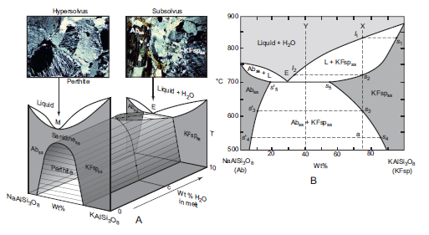
Figure 7(A) Schematic representation of effect of addition of H2O to liquid in the system NaAlSi3O8–KAlSi3O8 at 0.5 GPa. The minimum (M) in the anhydrous system changes to a eutectic (E) above a critical concentration (C) of H2O in the melt. The photomicrographs illustrate typical hypersolvus and subsolvus textures. (B) H2O-saturated phase diagram for alkali feldspars at 0.5 GPa. All phases coexist with an H2O-rich vapor. After Morse (1970).

It is important to note that, if the minimum coincide precisely with the top of the solvus, an eutectic
Results. On the other hand, if the minimum come down on the sodium- or potassium-rich side of the solvus, a peritectic results (Figs. 8 A and B, respectively)?
Because the eutectic in Fig. 7B lies to the sodium rich side of the solvus, the minimum may also be on this side, in which case the peritectic relation would be as shown in Fig. 8A. If the minimum is on the other side of the solvus, the peritectic relation would be like that shown in Fig. 8 B. Reactions at the peritectic result in the mantling of one feldspar by the other. Such textures are common in rocks. The result is that the peritectic in Fig. 8 B represents the reaction most commonly encountered in rocks; that is, potassium feldspar rims plagioclase. The position of the minimum is, however, affected by other factors in the melt, such as the activity of silica, and possibly under some conditions the peritectic of Fig. 8 A exists. This could explain the rapakivi texture, where potassium feldspar is rimmed by plagioclase. This texture is named for its presence in the granite from Rapakivi in Finland, which is commercially one of the most widely used facing stones in the world.

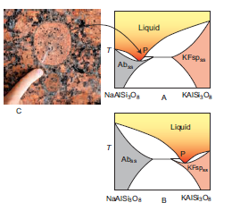
Figure 8 Possible peritectic relations in the alkali feldspar system. (A) Minimum is on the albite side of the solvus. (B) Minimum is on the potassium feldspar side of the solvus. (C) Rapakivi texture in granite with plagioclase rimming alkali feldspar phenocryst
Recall that, increasing the water pressure (P_{H2O}) will suppress the single feldspars field until when P_{H2O} is > 500 MPA at which the single feldspar field disappear completely and two separate feldspars (one K-rich and the other Na-rich) form (see 9 figure a-c).
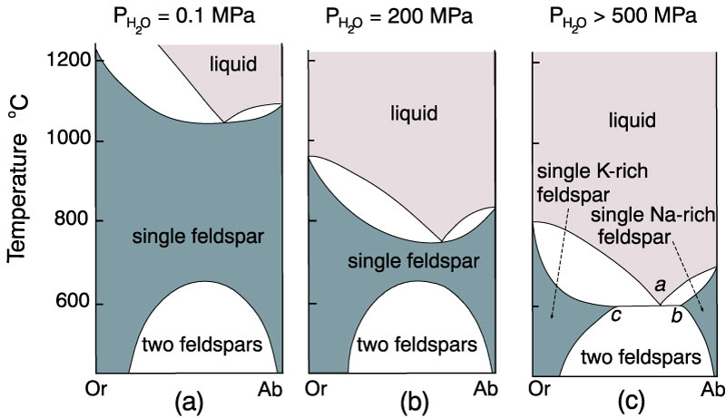

Figure 9: . The Albite-K-feldspar system at various H₂O pressures

TERNARY SYSTEMS
Ternary system can best be considered as combination of several binary systems in which the binary eutectics are known as the cotectics. Figure 10 shows a three-dimensional representation of the three component (ternary) system ABC. Note that composition is measured along the sides of the basal triangle and temperature (or pressure) is measured vertically. The top of the figure shows a surface with contour's representing lines of constant temperature. These contours are called isotherms. Note that the eutectic points in each of the binary systems project into the ternary systems as curves. These curves are called boundary curves, and any composition on one of these curves will crystallize the two phases on either side of the curve.

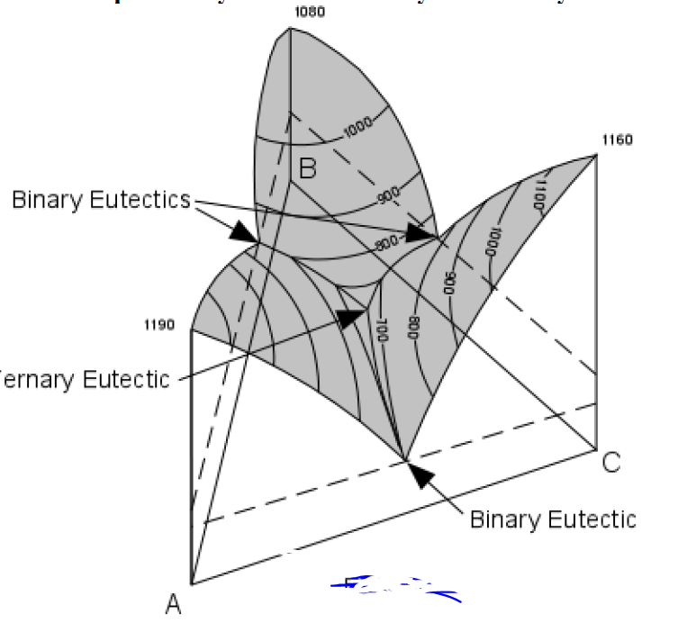

Figure 10: Ternary system in 3D.
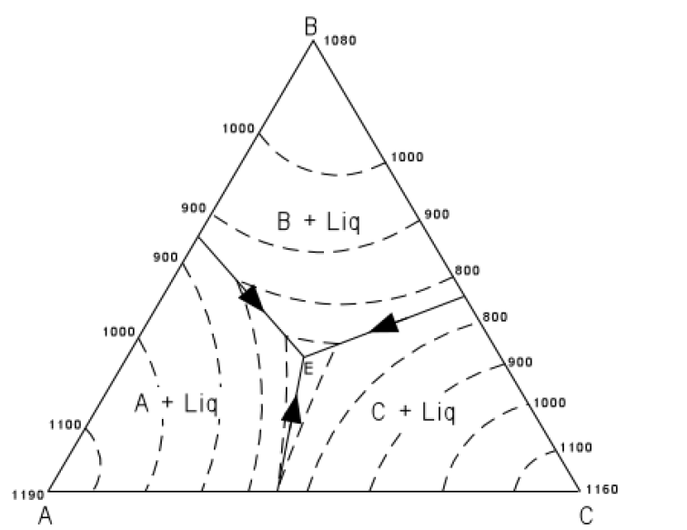
Figure 11 shows the same figure in two dimensions as seen from above. The boundary curves and isotherms are also shown projected onto the basal triangle. Note how the temperature decreases toward the center of the diagram.

Figure 11: Ternary system in 2D.

APPLICATION OF LEVER RULE ON TERNARY PHASE DIAGRAMS.
In Figure 10 we trace the crystallization of composition X. Figure 12 is the same as Figure 11, with the isotherms left off for greater clarity. Note that the final solid must consist of crystals A + B + C since the initial composition is in the triangle ABC. At a temperature of about 980° the liquid of composition X would intersect the liquidus surface. At this point it would begin to precipitate crystals of C. As temperature is lowered, crystals of C would continue to precipitate, and the
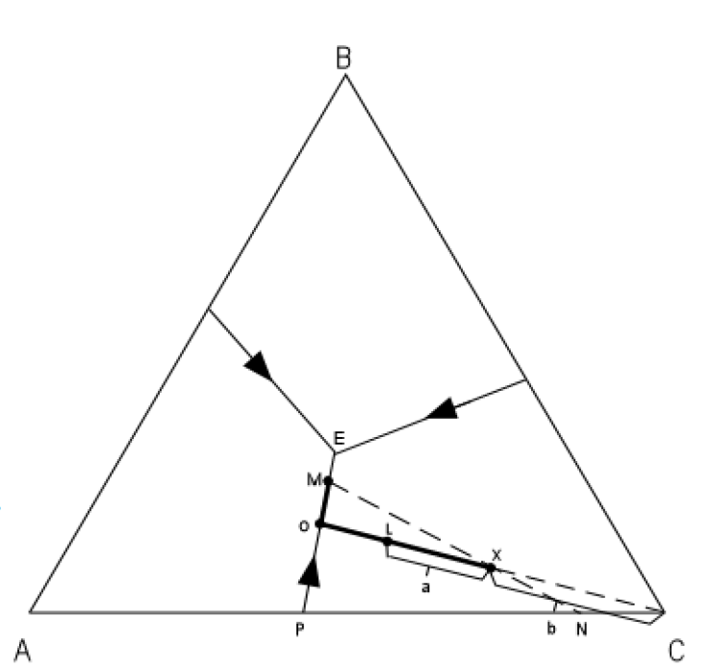
composition of the liquid would move along a straight line away from C. This is because C is precipitating and the liquid is becoming impoverished in C and enriched in the components A + B.

Figure 12.
At a temperature of about 820°, point L in Figure 10, we can determine the relative proportion of
crystals and liquid.
% crystals = a/(a+b)*100
% liquid = b/(a+b)*100
With further cooling, the path of the liquid composition will intersect the boundary curve at point 0. At the boundary curve crystals of A will then precipitate. The liquid path will then follow the
boundary curve towards point M. The bulk composition of the solid phase precipitated during this interval will be a mixture of A + C in the proportion shown by point P. At point M, the bulk composition of the solid phases so far precipitated through the cooling history lies at point N (the extension of the straight line from M through the initial composition X). At this time the % solid will be given by the distances:
(distanceMX/distanceMN)*100 and the % liquid by the distances: (distanceXN/distanceMN)*100
Note, however, that the solid at this point consists of crystals of A and crystals of C. So, we must
further break down the percentages of the solid. This is done as follows: The percentage of the solid that is A will be given by the distance from C to N relative to the distance between A and C; i.e. by the formula:
%A in solid = (distanceNC/distanceAC)*100
Similarly, the percentage of the solid consisting of crystals of C is given by the formula:
%C in solid = (distanceAN/distanceAC)*100
We can now calculate the exact percentage of all phases present in composition X at a temperature of 660° (where the liquid composition is at point M). The following formulae apply:
%A crystals = %A in the solid * %crystals/100
or
%A = (distanceNC/distanceAC)*100 * (distanceMX/distanceMN), and
%C crystals = %C in the solid * % crystals/100
or
%C = (distanceNA/distanceAC)*100 * distanceMX/distanceMN
Note also that we can determine the composition of all phases present in the system at this point. The composition of the liquid is given by reading the composition of point M off the basal triangle. Since it is a mixture of A, B, and C, it will have a composition expressed in terms of the
percentages of A, B, and C. The composition of the solids are 100%A and 100% C; i.e. they are
pure solid phases (not mixtures).
With further cooling, the liquid composition will move to the ternary eutectic, E, at a Temperature of about 650°, at which point crystals of B will precipitate. The temperature will remain constant until all of the liquid is used up. The final crystalline product will consist of crystals of A + B + C in the proportions given by the initial composition X. Crystallization will proceed in an analogous manner for all other compositions in the ternary system. To summarize, we can express the path of crystallization for composition X in an abbreviated form as follows:
T > 980° All Liquid
980°-680° Liq + C
680°-650° Liq + C + A
T = 650° Liq + C + A + B
T < 650° C+ A + B (all solid)
Note, application of lever rule in ternary phase diagrams have also been discussed in class. Students can refer to the lecture power point for more examples.

- The Forterite (Mg₂SiO₄)– anorthite (CaAl₂ Si₂O₈₎ – diopside (CaMgSi₂O₆) system
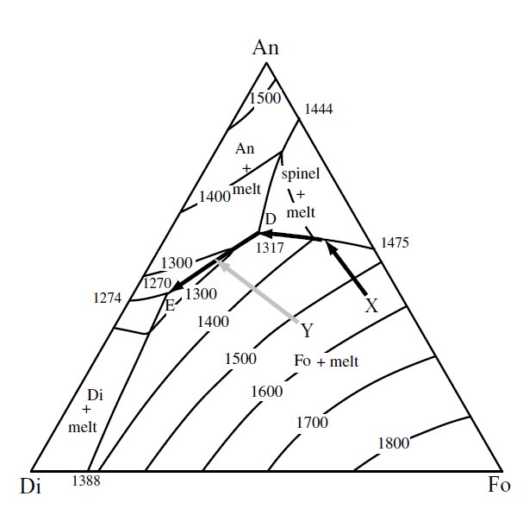
The ternary system Mg2SiO 4 – CaAl 2 Si 2O8 – CaMgSi2O 6 is an analog for a basaltic melt. Figure 13 shows that the system has four, rather than three, fields of primary crystallization. In addition to fields of olivine + melt, diopside+ melt, anorthite + melt, the system requires an additional field for spinel + melt. The composition of spinel lies outside of the Fo-An-Di compositional triangle. A system that has one or more phases that lie outside of the plane of a ternary diagram is known as a pseudoternary system. Even though, strictly speaking, the system Fo – An – Di is pseudoternary, for most compositions it behaves like a true ternary system.

Figure 13: Ternary phase diagram for the system Fo – An – Di showing the crystallization path followed by melts of the composition X and Y. D = ternary peritectic and E = ternary eutectic.

Equilibrium crystallization. Consider how crystallization proceeds for a melt with the composition X on Figure 13. The first crystals, olivine, form at temperatures slightly below 1600°C. As temperature falls, the crystallization of olivine drives the melt composition directly away from the olivine apex. At temperatures slightly above 1400°C, spinel joins olivine as a crystallizing phase. As temperature falls to 1317°C (at point D), spinel reacts with the melt to make forsterite + plagioclase. Point D is a ternary peritectic that is analogous to the binary peritectic in the system Fo – SiO2 . A melt that was originally rich in spinel component is exhausted at the peritectic, whereas melts with a composition like X consume spinel by the peritectic reaction. At temperatures below 1317°C, olivine and plagioclase are the crystallizing phases and their crystallization drives the melt along the cotectic toward the eutectic (point E). At the eutectic (1270°C), diopside joins the crystallizing phases and olivine + diopside + plagioclase crystallize together until the melt is entirely consumed. If the melt started with the composition Y on Figure 13, olivine crystallization forces the melt composition directly away from the Fo apex and toward the plagioclase-olivine cotectic (gray line in Figure 13). Melts of this composition miss the peritectic at point D and intersect the plagioclase-olivine cotectic at temperatures slightly below 1300°C. Plagioclase then joins the crystallizing assemblage, driving the melt composition to the eutectic.

Fractional Crystallization: Consider what happens to a melt of composition Y in Figure 14 during fractional crystallization. The olivine formed during initial crystallization stages sinks to the bottom of the magma chamber, accumulating a layer of dunite. Once the melt reaches the cotectic, fractional crystallization deposits a layer of plagioclase + olivine, producing a rock called a troctolite. Once the eutectic is reached, the residual melt crystallizes to an assemblage of diopside, anorthite, and olivine, which together compose olivine gabbro. Although the layered sequence of
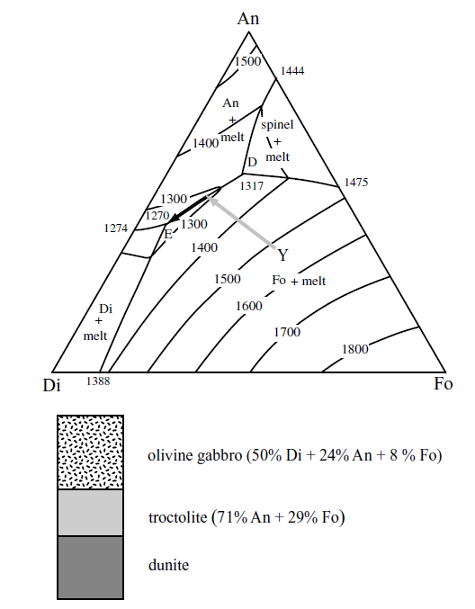
rocks formed by this process (shown schematically in Figure 13) is an extreme simplification, it provides a good illustration of the kinds of crystallization processes that may form layered mafic intrusions.

Figure 14: Ternary phase diagram showing the sequence of rocks produced from a melt with a composition Y that has undergone fractional crystallization and crystal settling. Mineral proportions are determined from the lever rule.

- Ternary Peritectic System
(The forsterite–anorthite–silica system)

In the ternary system forsterite–anorthite–silica, the presence of an incongruently melting binary compound introduces a ternary peritectic, but there is still only one ternary eutectic (Figure 15).
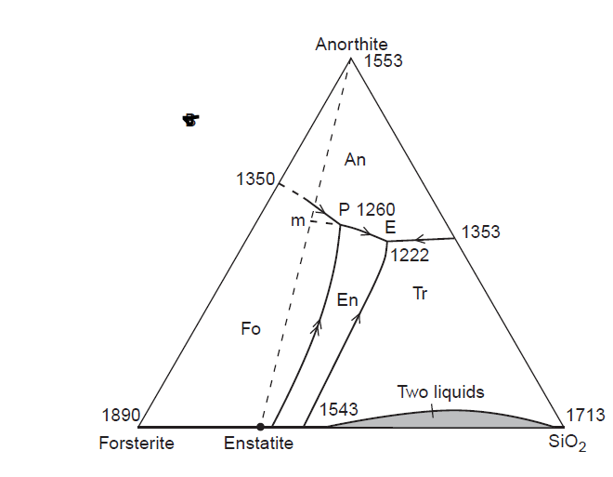

Figure 15: System forsterite–anorthite–silica at atmospheric pressure showing Projection of liquidus relations onto compositional triangle. Temperatures are in °C
Equilibrium crystallization: Consider the crystallization of a liquid with composition A in Figure 16. First, A plots in the subtriangle An–Fo–En; under equilibrium conditions, therefore, it must eventually crystallize to these three minerals. But only at the ternary peritectic, P, do these minerals coexist with a melt. Liquid A must therefore eventually crystallize at this point. Initially, however, olivine crystallizes from liquid A. This depletes the melt in forsterite and changes the composition of the liquid in a straight line away from forsterite until it reaches the reaction curve at l1. Because forsterite is the only mineral to crystallize during this initial stage, the composition of the solids must be represented by s1. As the liquid follows the reaction curve from l1 to the ternary peritectic, P, forsterite reacts with the liquid to produce enstatite. The bulk composition of the solids, therefore, moves from s1 towards enstatite, reaching point sP when the liquid reaches the peritectic. The composition of the solids at any stage of crystallization is determined by drawing a line from the liquid through the initial bulk composition (A) to the line joining the crystallizing phases. The additional phase and decreased variance at the peritectic means that the liquid can no longer change its composition. It must therefore crystallize forsterite (negative amount), enstatite, and anorthite in the proportions given by point P (any other point would change the liquid’s composition). Addition of a mixture of solids of composition P to the already formed solids moves the bulk composition of the solids from Sp toward P. But in doing so, the solids approach and eventually reach composition A, at which point the peritectic liquid is exhausted and a mixture of crystals of forsterite, enstatite, and anorthite is free to cool. The crystals of forsterite that first form in liquid A are euhedral (Fig. 16 ), but when the liquid reaches the reaction curve they become rounded and rimmed by enstatite.
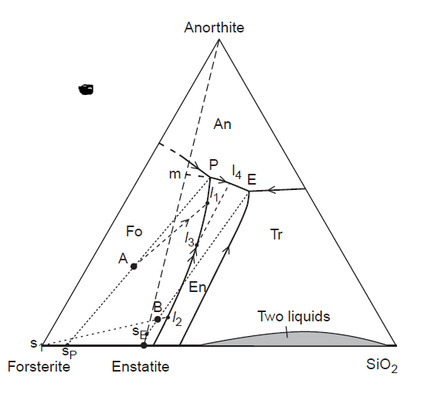

Figure 16: System forsterite–anorthite–silica at atmospheric pressure showing Construction lines used in following crystalliz ation paths. See text for discussion

As an additional example, let us now consider the crystallization of a liquid with composition B in Figure 16. This liquid also first crystallizes olivine, but because the liquid plots in the subtriangle An–En–SiO2, it must eventually crystallize at the ternary eutectic. Early crystallization of olivine moves the composition of the liquid from B to l2 on the reaction curve, whereupon enstatite begins to form. As the liquid follows the reaction curve, the solids change their bulk composition from olivine toward enstatite. When the liquid reaches l3, all forsterite must be consumed by reaction. This can be shown by drawing a straight line from the liquid through the bulk composition, B, to the forsterite–enstatite join; this line passes through enstatite, and thus no forsterite remains. The loss of this phase increases the variance by one, and the liquid is free to leave the isobaric univariant reaction curve. Because enstatite is the only phase crystallizing, the liquid moves directly away from enstatite across the enstatite liquidus to l4, where it intersects the anorthite liquidus. Note that whereas enstatite originally forms only as a reaction product around forsterite, on leaving the reaction curve, it crystallizes directly from the melt and would consequently form euhedral crystals. At l4, anorthite begins to crystallize, so that the solids are now represented by points on the line En–An. For example, when the liquid first reaches the ternary eutectic, the solids have a composition represented by point sE. To this composition, a eutectic mixture of En–An–Tr is added, which eventually moves the composition of the solids to the initial starting composition, B, at which point the eutectic liquid is exhausted.
Under equilibrium conditions, liquid of composition B would give rise to a rock composed of phenocrysts of enstatite, smaller phenocrysts of anorthite (because it forms later) in a eutectic groundmass of enstatite, anorthite, and tridymite. If the starting liquid had been a little less rich in anorthite, the fractionating liquid would have encountered the tridymite liquidus before that of anorthite, in which case there would have been phenocrysts of tridymite, and anorthite would have been restricted to the eutectic groundmass.
PETROLOGICAL SIGNIFICANCE OF THE FORSTERITE–ANORTHITE–SILICA SYSTEM
During fractional crystallization, the early crystallizing olivine sink and separate from the liquid with which it should react. In this way, a magma of composition A in Figure 16 could fractionate all the way to the ternary eutectic. This process is extremely important in producing a diversity of igneous rocks in large intrusions where there is sufficient time for separation of early crystallizing minerals from the magma.

CALC-ALKALINE AND ASSOCIATED ROCKS
INTRODUCTION
The modern definition of the calc-alkaline rocks is based on the AFM diagrams (Figure 1). On this diagram, calc-alkaline rocks show a trend along which the ratio of MgO to total iron (MgO/FeO*) remains nearly constant. This trend is known as calc-alkaline trend. On the other hand, some suites of igneous rocks show characteristic of systematic iron enrichment with increasing degree of magmatic differentiation, a geochemical feature that is generally referred to as a tholeiitic trend. The difference between tholeiitic and calc-alkaline magma sources is quite evidently related to their oxygen fugacity. In reduced magmas, Fe is removed slowly by crystallization of Mg-rich ferrous minerals such as olivine and pyroxene. This results in an increase of the Fe/Mg ratio during the initial stages of magma evolution, producing the tholeiitic suite of rocks. On the other hand, oxidizing conditions in a parent magma promote the crystallization of ferric iron-bearing magnetite, which removes Fe more efficiently, producing the calc-alkaline trend. However, it is important to note that calc-alkaline magmas are typically generated at the subduction zone and hence have high water pressure, which depresses the plagioclase liquidus leading crystallization of considerable anorthite-rich-SiO₂-poor plagioclase and low-silica, high-Fe hornblende. The crystallization of anorthitic plagioclase as well as low-silica, high-Fe hornblende is an alternative mechanism for the origin of calc-alkaline trend.

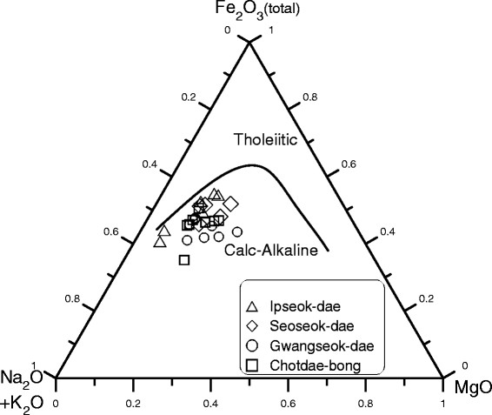
Figure 1: A (alkali), F (total iron) and M (magnesium) digrams
Tectonic Settings
The division of igneous rocks into tholeiitic and calc-alkaline suites makes sense in a plate tectonic context. Tholeiitic rocks are found at mid-ocean ridges, where decompression melting of the upper mantle produces primitive magmas without crustal contamination. Calc-alkaline rocks are found at convergent margin usually in subduction zones, where dehydration of the down going slab interacts with the mantle wedge and the overriding plate, resulting in a mixing of different magma sources, thus providing ample opportunity for the introduction of oxidized chemical species into the system.
Geochemical Features of Calc-alkaline Rocks
Calc-alkaline rocks have distinctive geochemical characteristics. Notably, many exhibits variable enrichments in large-ion lithophile elements (LILE; e.g., Ba, Sr, K, Rb, and Cs) and fluid-mobile elements (FME; e.g., B, Pb, As, and Sb), whereas they are commonly depleted in high field-strength elements (HFSE; e.g., Nb, Ta, Zr, and Hf) relative to typical intraplate oceanic island basalts (OIB) and mid-ocean ridge basalts (MORB). These features are usually attributed to selective enrichment of arc magma sources by slab-derived LILE-enriched aqueous fluids or melts.
Petrological association and Economic Significance
Among the calc-alkaline suites of rocks, Andesite is normally the most abundant volcanic rock, but many others rocks, ranging from basalt (gabbro) to rhyolite (granite), are present and can predominate. The proportions of various rock types largely on the types of plates involved in the convergence. Oceanic plates tend to produce higher proportions of basaltic rocks, whereas continental ones produce more silicic rocks.
Most calc-alkaline rocks are spatially and temporally related to major porphyry copper and molybdenum deposits, which are the major source of Cu and Mo in the world. Calc-alkaline rock may also may associated with economically significant gold deposits.
Origin of Andesite
Andesite is an intermediate volcanic rock typically emplaced at the subduction (or arc) setting. It is commonly believed that andesitic lavas are dominantly erupted in many if not most volcanic arcs, and that they are essential building blocks for continental crust—that itself is estimated to be generally “andesitic” in composition. Thus, understanding the origin of andesite can yield important clue regarding the origin of continental crust. Four end-member models have been proposed for the origin of andesites. They include: :1) crystal fractionation of hydrous basalt (in the upper, middle, and/or lower crust); (2) partial melting of hydrated, mafic lower crust; (3) magma mixing of basalt with rhyolite/dacite; and (4) assimilation of granitoid upper crust by basalt/basaltic andesite.

ALKALINE ROCKS
Alkaline igneous rocks may be defined as those which have higher concentrations of alkalis than can be accommodated in feldspars alone, the excess appearing as feldspathoids, sodic pyroxenes, sodic amphiboles and other alkali-rich phases. These rocks are, therefore, deficient in silica and/or alumina with respect to alkalis and will have nepheline and/or acmite in their norms. Based on the molar ratios of Na₂O+K₂O relative to Al₂O₃, alkaline rocks can be subdivided into metaluminous [(Na₂O+K₂O) < Al₂O₃ < (CaO+ Na₂O+K₂O)] and peralkaline (Na₂O+K₂O> Al₂O₃) types. Conclusively, this means that an alkaline rock should belong to the metaluminous or to the peralkaline group, although rare peraluminous (Al₂O₃> CaO+ Na₂O+K₂O) alkaline rocks do occur. Note that peralkaline rocks may be silica-oversaturated (i.e., quartz in the norm), and examples include peralkaline rhyolite, aegirine–riebeckite granite, or they may be silica under-saturated and have nepheline, leucite, and other feldspathoids in the norm, e.g., nepheline syenite or phonolite.
Silica under-saturated peralkaline rocks can be divided into miaskitic and agpaitic types. Miaskitic are peralkaline rocks in which most of the high field strength elements (HFSE) such as Ti, Zr, Hf, Nb, Ta are accommodated within accessory zircon and titanite± Fe-Ti oxides (ilmenite or Ti-bearing magnetite). On the other hand, agpaitic rocks are special group of peralkaline rocks that contains one or several complex Na-K-Ca-(Fe)-silicates, which are rich in Ti or Zr, the most prominent of these being eudialyte, aenigmatite and astrophyllite. In these rocks, zircon, titanite and Fe-Ti oxides are either scarce or absent.

Geochemical Features, Economic Significance Tectonic Setting and Origin
Alkaline rocks are rich in both large ion lithophile elements (LILE) such as Na, K and Li and high field strength elements (HFSE) such as Ti, Zr, Hf, Nb, Ta. They are also rich in rare earth elements (REE), U and Th, potentially forming economically important deposits of these elements.
Alkaline rocks are typically emplaced in intraplate extension or rift-related settings. There emplacement generally marked a period of crustal relaxation that followed a prolonged hiatus after major orogenic events.
Alkaline rocks typically formed from parental magmas that were generated through low degree partial melting of an enriched mantle. However, few alkaline rocks especially those that are silica-oversaturated may formed from parental magmas that were generated through partial melting of the lower crust.
Alkaline Magma Differentiation: Petrogeny’s Residua System
The system nepheline–kalsilite–silica (Fig. 2) has played an important role in our understanding of differentiation of silica-saturated and silica-unsaturated (alkaline) magmas. In this system, Phases appearing on the liquidus are the silica polymorphs cristobalite and tridymite, their liquidus fields separated by an isothermal boundary at 1470°C, the alkali feldspars, showing complete solid solution between albite and orthoclase. Leucite also shows extensive solid solution towards more sodic compositions, and nepheline and kalsilite showing extensive solid solution towards each other. The high-temperature polymorph of nepheline, carnegieite, also appears on the liquidus. Only liquids more potassic than leucite crystallize kalsilite, and these are extremely rare in nature.
The system contains three minima, which lie in what Bowen called a "thermal valley" and approximate the compositions of rhyolite (m_{s}), trachyte (m) and phonolite (m_{ne}). (The point m is actually a binary minimum in Ab-Or.) These minima closely represent the natural residua from fractionation of, respectively, tholeiites, critical plane basalts (transitional basalt), and alkali basalts, and it is for this reason that Bowen aptly called the system Ne-Ke-SiO₂ "petrogeny's residua system."
The alkali feldspar join, where it crosses the alkali-feldspar + L field constitutes a thermal divide and fractionation paths within the alkali feldspar field are shown diagrammatically in Figure 3. Within the leucite field, an under-saturated melt can easily breach or cross the alkali feldspar join (thermal divide) toward silica saturation by fractionation of leucite, but only for potassic compositions at low pressure (Figure 3a-b). Because at high pressure the leucite field will disappear. Intermediate or sodic under-saturated compositions will fractionate toward the under-saturated minimum. However, open system behavior such as assimilation of silicic crustal material can permit an initially under-saturated melt (sodic, potassic or intermediate) to fractionate toward silica saturation or silica over-saturation.

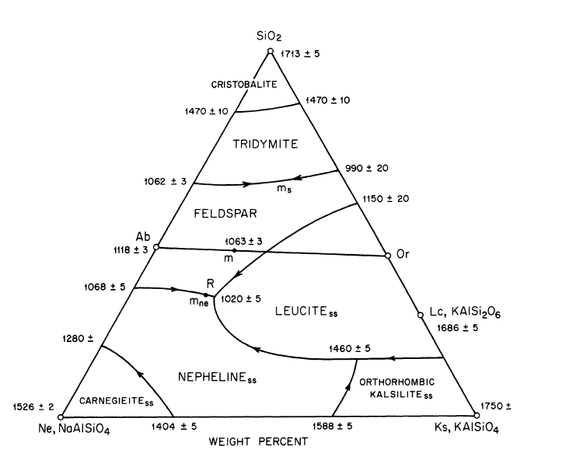

Figure 2: The system nepheline–kalsilite–silica.
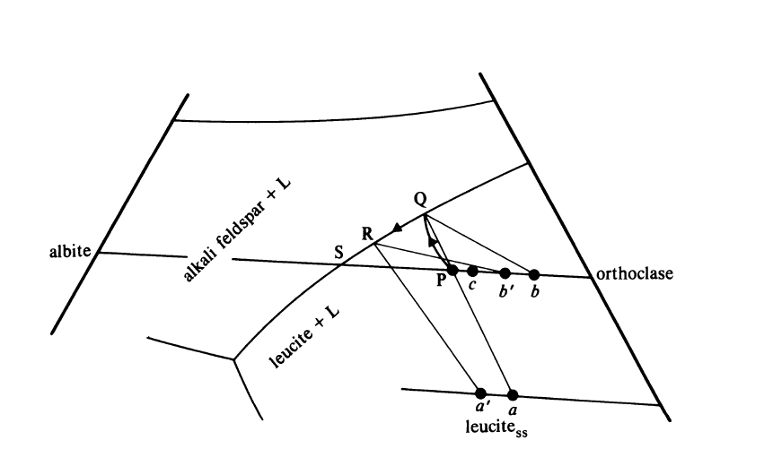
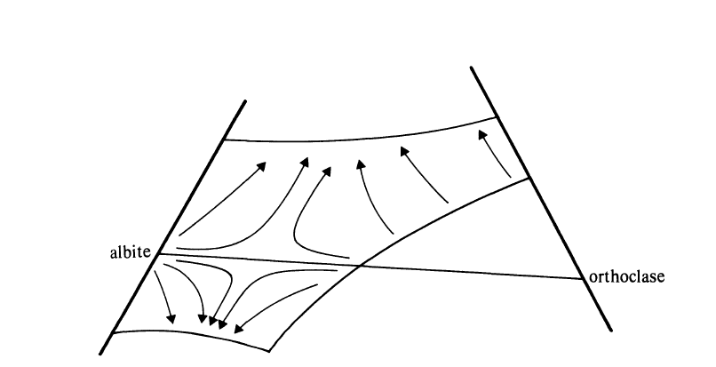
b
a

Figure 3a-b: Fractional crystallization of bulk compositions falling in the sodic and leucite + L field of the system nepheline-kalsilite-silica.
The Syenite-Trachyte Problem: A Thorn in Igneous Petrology?
It is important to understand what basaltic liquids may become on fractionation. In general, as Bowen long ago pointed out, they yield residua closely modelled by the system Ne-Ks-SiO₂, and more specifically, these residua tend to lie in a relatively limited region, which Bowen called a "thermal valley", encompassing the three minima, m_{ne}, m, and m_{s} (Fig. 4). Natural rocks closely corresponding to these three compositions occur in abundance, and their extrusive equivalents are called, respectively, phonolite, trachyte, and rhyolite. We may therefore speak informally, and quite appropriately, of the phonolite minimum, trachyte minimum, and rhyolite minimum. These are the logical and quite often defensible residua from fractionation of alkali basalt, critical plane basalt, and tholeiite, respectively.
In terms of actual liquidus temperatures, Bowen's thermal "valley" is not a valley at all, but a saddle, or negatively curved surface, with a culmination at the trachyte (syenite) minimum at 1063°C. If this is a saddle, the Ab-Or join is the horse, and cantle and pommel slope toward m along the feldspar join itself. The culmination, or seat, then slopes off away from the join- toward m_{s} and m_{ne}' A cross section through the liquidus surface along the general line (transverse to the horse) through or near the three minima is shown in Fig. 5. This section is drawn to scale, and it leaves no doubt that m is a pronounced maximum relative to m_{ne} and m_{s}. It shows, furthermore, the very steep liquidus slopes leading to the two "minima", especially from the directions of nepheline and silica. The feldspar minimum m is simultaneously a minimum in Ab-Or and a maximum relative to m_{ne} and m_{s}. It is therefore somewhat surprising that trachytes (or syenite) exist at all, for one would suppose that the slightest deviation of a bulk composition from the critical plane (or feldspar plane) would lead to phonolitic or rhyolitic residual liquids. The common existence of trachytes and syenites requires, then, some mechanism for keeping liquids in the critical condition during fractionation, as well as a non-unique source mechanism for generating critical-plane liquids in the mantle. The fractionation control need only be minor if initial liquid are strictly of the critical-plane type, for then they will have no inherent tendency to fall away from the feldspar join hence can easily form trachyte (or syemite). But the source controls for generating such liquids repeatedly in the mantle are essentially unknown, and the "syenite problem" seems to remains a thorn in the side of igneous petrology.

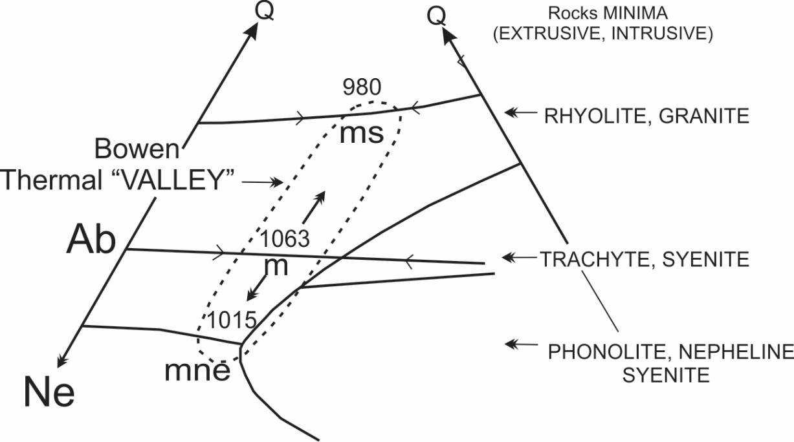

Figure 4: Bowen's thermal "valley" in the residua system.

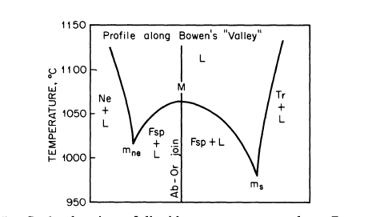

Figure 5: Scale drawing of liquidus temperatures along Bowen's thermal "valley". The line of section connects the three minima, but may not be straight through M.

Origin of Syenite (or trachyte): There are syenites and syenites!!!
On the one hand, some researchers argue that in the system NaAlSiO+-KAlSiOa-SiO2 at low pressure, a basalt of critical plane composition will not yield syenite (or trachyte) because there is no barrier for such basalt to fractionate directly to produce phonolite or rhyolite. On the other hand, some researchers suggest that during fractionation of basalts lying slightly to either side of the thermal divide, the residual liquids are sufficiently enriched in alkalis to become trachytic (or syenitic) long before the ultimate phonolitic or rhyolitic residues can be produced.
Consequently, there are two models for the origin of syenite: The first model which is known “magma mush model” suggests that syenite can be produced through accumulation of alkali feldspar and minor mafic crystal mushes, whereas partial melting of the syenite due to magma recharge produces trachytic melt. Syenites and trachytes that form through this process usually display cumulate textures and positive Eu anomaly (e.g the syenite in Daura Complex, Nigeria).
The second model, which is known as the fractional crystallization model, suggest that syenite can form through fractional crystallization of basaltic melt. Syenite that form through such process usually lack cumulate texture and display negative Eu anomaly (e.g the syenite from Zaranda Complex, Nigeria).

